Rui Da

10/21/2014

Restaurant Management System

Order Scenario

1. Waiter Alex takes guests to their table. He clicks on “Order” button and types in his name and table number, which is 1. Click “Submit”, 2 rows of guest information should display.

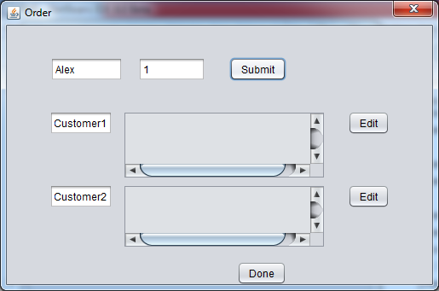

2. Click on “Edit” button for guest 1 to make order. Choose 1 chicken wings and 1 beef ramen.

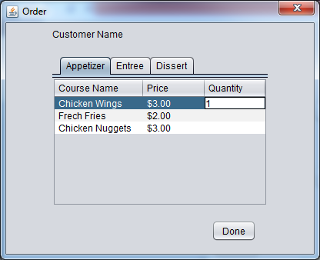

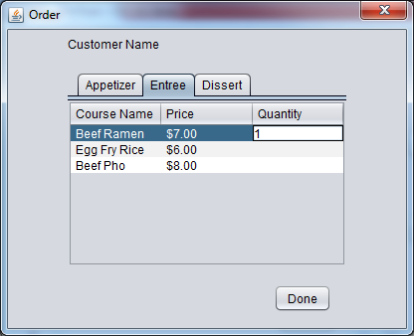

3. Click on “Done”. Order information for guest 1 should display.

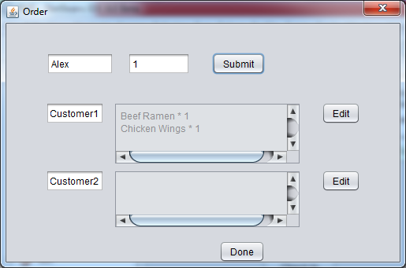

4. Click on “Edit” button for guest 2 to make order. Choose 1 coconut ice cream and 1 beef ramen. Click on “Done”. Order information for guest 2 should display.

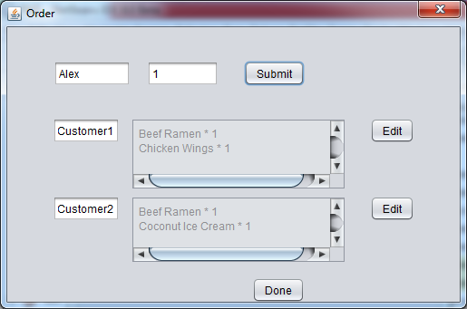

5. Click “Done” button, order summary for both guests should display.

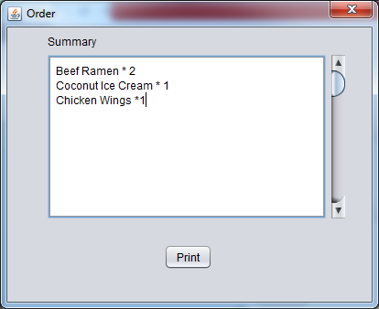

6. Click “Print”, return to main window.

